**This is a document about the movement of characters, bosses, and enemies in the game**

**Neotech Nuke Gang**

Neotech Nuke Gang are thugs, thugs with robot parts. Watch out for their blasts, kicks, and eye beams.

Lets take games like x-men,the simpsons, tmnt, castle crashes, scott pilgrim. Only this game you will stay on a flat platform and you only jump and move across. Thinking this way we can say that we have to use the directions to do different things. Think of it as like a sort of fighter style game.

Walking stand special

1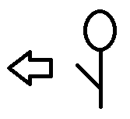 1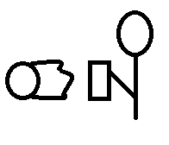

2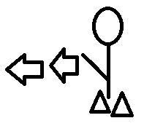 2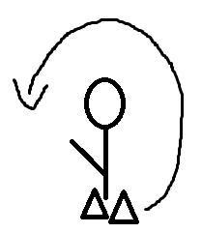

3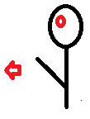 3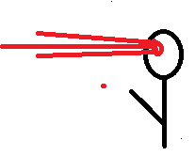

Neotech (legs) is the only one who moves faster than juan however only slightly faster I’ll say 5% faster. The others however are 35% slower than juan. The nuke gang punch length and kick length is the same as neon juan. They use their special techniques randomly. Neotech (arm) uses his cannon that shoots like a hadoken. It is 50% faster than a regular hadoken. Neotech (legs) does a flip kick which is a front flip. Neotech (eye) uses a beam, the first one being non-damaging which gives a warning that the actual beam is about to shoot. The beam only does damage to neon juan but it fills the screen. Their special attack damage does the damage if they was on the final level. So if they did 5*(how many levels) and there was 7 levels the damage would be 35. (confused on this? Check the health and damage doc)

Going off of how tall and wide neon juan is we will use him as a base.

Neotech (legs) are 1 inch taller.

Neotech (arms) is 2 inches wider (due to muscles)

Neotech (eye) same size as neon juan. (time period before he shoots let it be 2 seconds, so if you see the warning beam you have two seconds to duck or jump)